**The basics**

**How an Angular App gets Loaded and Started**

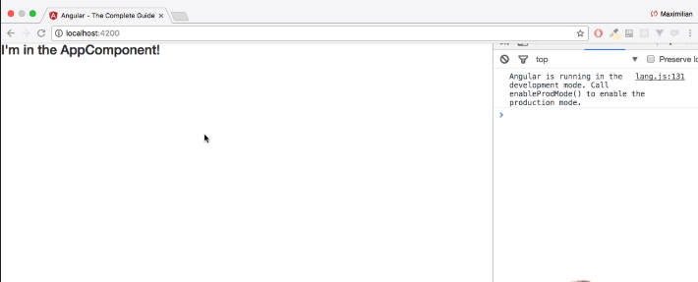

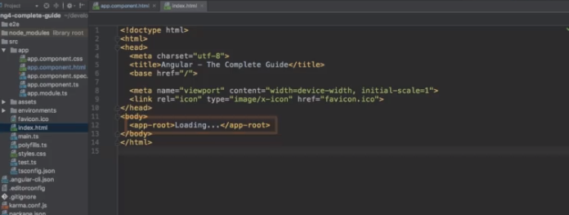

**Components are Important!**

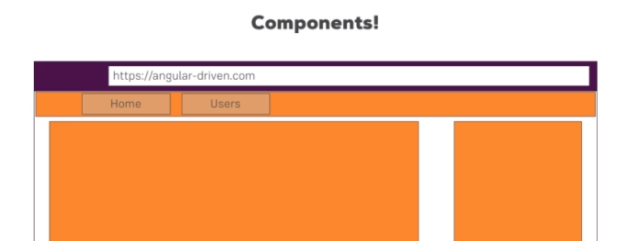

**Creating a New Component**

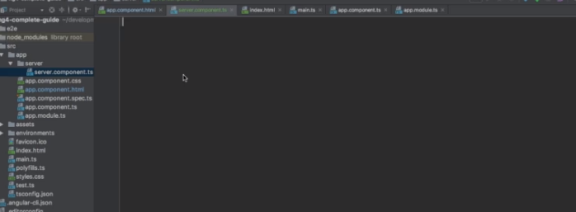

**Understanding the Role of AppModule and Component Declaration**

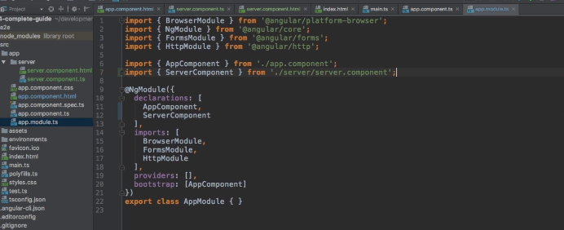

**Using Custom Components**

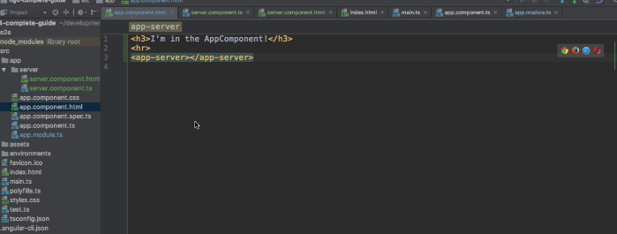

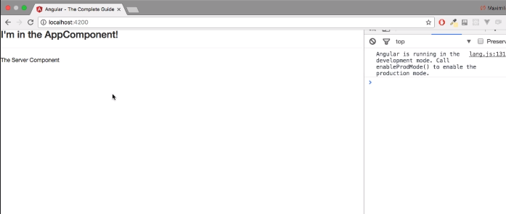

**Creating Components with the CLI & Nesting Components**

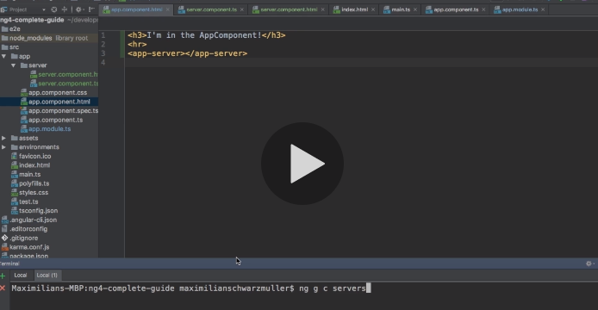

**Working with Component Templates**

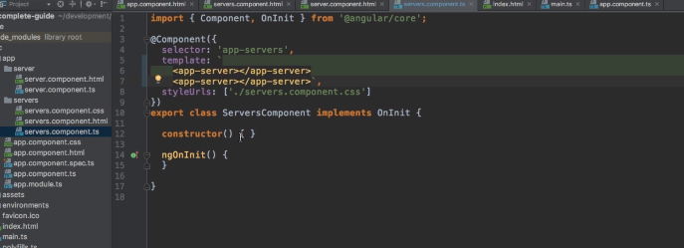

**Working with Component Styles**

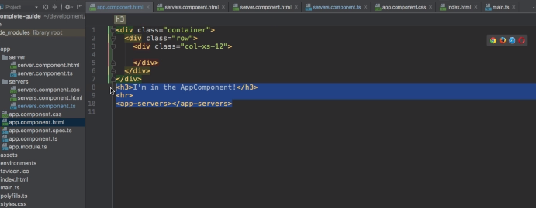

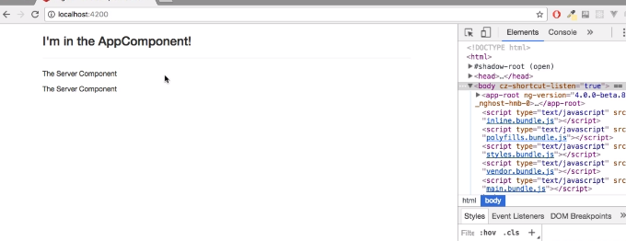

**What is Databinding?**

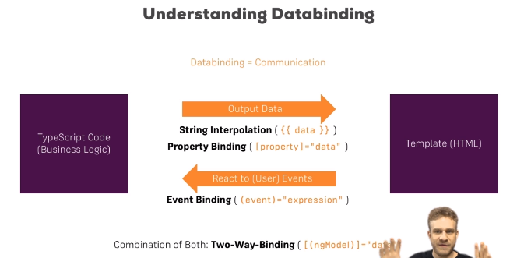

**Bindable Properties and Events**

How do you know to which Properties or Events of HTML Elements you may bind? You can basically bind to all Properties and Events - a good idea is to console.log()  the element you're interested in to see which properties and events it offers.

**Important**: For events, you don't bind to onclick but only to click (=> (click)).

**Important: FormsModule is Required for Two-Way-Binding!**

Important: For Two-Way-Binding (covered in the next lecture) to work, you need to enable the ngModel  directive. This is done by adding the FormsModule  to the imports[]  array in the AppModule.

You then also need to add the import from @angular/forms  in the app.module.ts file:

import { FormsModule } from '@angular/forms';

**Two-Way-Databinding**

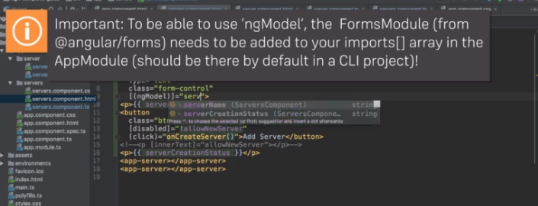

**Combining all Forms of Databinding**

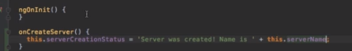

**Using ngIf to Output Data Conditionally**

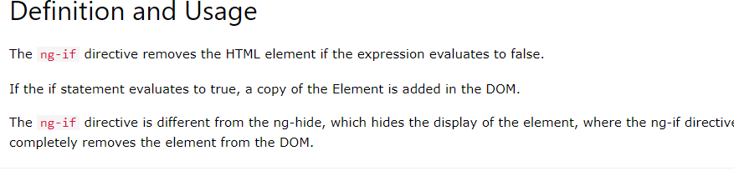

**Enhancing ngIf with an Else Condition**

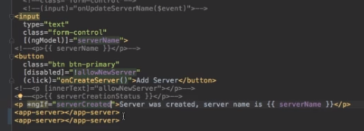

**Styling Elements Dynamically with ngStyle**

https://paper-attachments.dropbox.com/s_D7D6548D6FAF5AB385F8C22E2F8ACA0B59513B335559DCAAB460E78B6DEB9C6F_1638002876305_screenshot-www.udemy.com-2021-11-27-14-17-51-816.png